

[Home appliances control with voice and mobile application]

[Research Paper]



Rohan Sharma, Yatharth Dubey, Aditya saxena, rohit gupta

B. TECH (c.s.e), Rungta college of engineering and technology

kurud rd, kohka, bhilai, chhattisgarh, 490024

**Abstract**

The main objective of this Research paper is to guide those people who wanted to convert their normal homes to an automated home. As a part of Home automation here you will learn how to control your Home appliances with the Voice and Mobile application command. The voice command is working on the principle of Speech recognition system for converting our voice commands into text form and then that text form is sent to the microcontroller via Bluetooth module. Also, our Mobile application command is sent to the microcontroller via Bluetooth module. First the microcontroller will match our text form command with its internal commands, if there is a match then microcontroller will give signal to the relay module to power on or off that particular appliance.

***Keywords:*** IOT, Home automation, Speech recognition, Mobile application.

**1. Introduction**

Smart homes are the basic need of today’s modern world. The demand for Smart homes is rapidly increasing. Nowadays everyone is so much busy or lazy that they don’t even want to spend their time going to the Switch board and switching the devices on/off. Also, it is very difficult for the Old-aged people and Physically disabled people. This project makes the connection of Android phone with the Embedded system and then with the appliances.

After this project, your dream of controlling home appliances via your voice and mobile application command will comes true. It helps in saving electricity. Also, its installation is affordable and maintenance is easy. Those who do not have much technical expertise will also be able to send commands to their appliances through voice and mobile application, but before that they will have to call a techie to make their homes smart. In our project the home appliances used are: a light bulb, a fan, a led light strip, and a socket.

**2. Circuit Diagram**

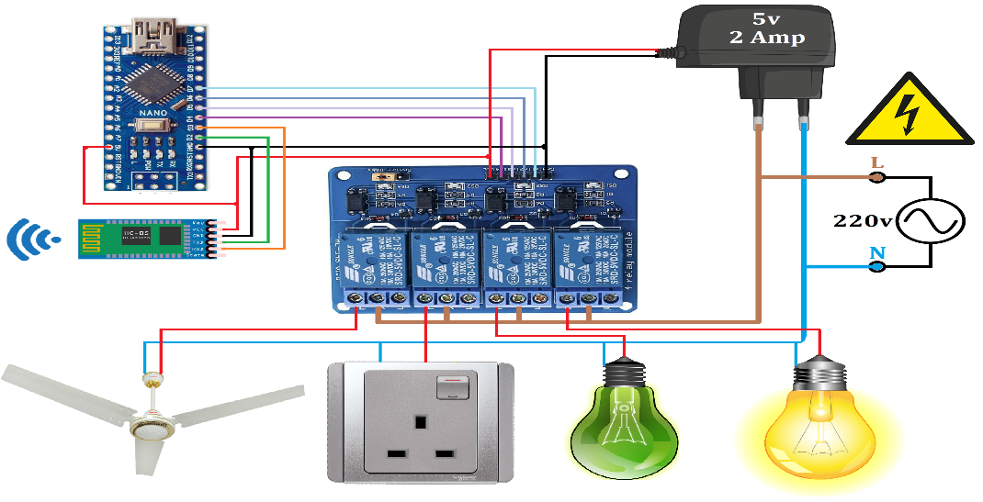

**3. Mobile Application Interface**

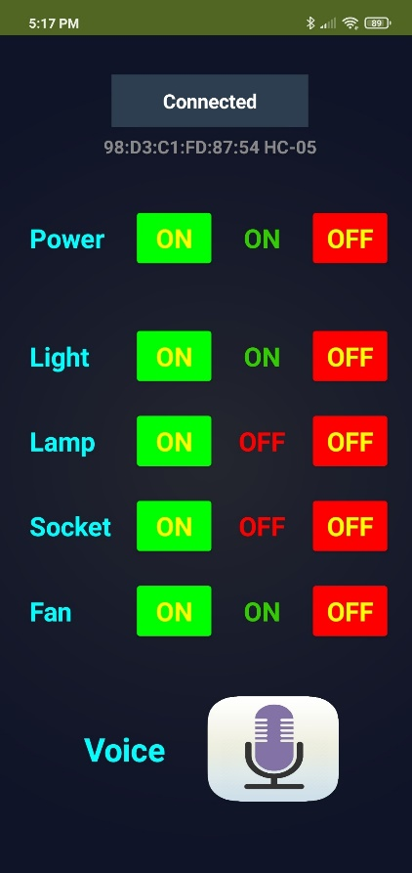

**4. Methodology**

**4. 1. Required components**

* **Android Phone**
* **Arduino Nano**
* **Bluetooth Module (HC-05)**
* **Relay Module (4-channel)**
* **Jumper Wire**
* **Home Appliances**

**4. 2. Some brief detail of components**

* **Arduino Nano**

The Arduino Nano is a small breadboard-friendly board based on the Atmega328 (Arduino Nano 3.x). It is widely used in robotics, embedded systems, IOT, industrial projects.

* **Bluetooth Module**

Bluetooth module used in this project is (HC-05). It is very cheap and it also fulfill all the required features for making of smart home. It is used to connect with other Bluetooth enabled devices like smart phones, laptops, etc.

* **Relay Module**

Relay module used in this project is 4-channel, 5-volt. Relay module is work like regulator switch for the home appliances. Each channel needs a 15-20mA driver current. It is connected and controlled by the microcontroller.

* **Software used**
  + **Android app**

The android app used in this project is created in “MIT App Inventor” (a web application). It mainly supports the android operating system.

* + **Arduino ide**

It is an open source ide which is used to create an .ino file that is uploaded to the microcontroller. It is platform independent.

**4. 3. Working**

This project is mainly used for making homes smarter. At first, we have to connect our Bluetooth module with the Android phone’s inbuilt Bluetooth. Now we have to install an Android application in our Android phone for the interface to command via button click. After clicking the Mobile application on/off buttons some commanding signals were generated and will go to Arduino via Bluetooth. Also, the Mobile application contains one voice button which is based on the Google Api. By pressing the voice button and speaking something the voice that is there will be converted into the text form. The Bluetooth module and Relay module are connected with the Arduino nano as seen in the circuit diagram. The Relay module is connected to the electric power(load). Now when the Microcontroller receives the command from the mobile, it checks whether the mobile command is matching with its backend command or not, and if it matches then it gives the command to the Relay module to operate the power supply.

|  |  |
| --- | --- |
| **Voice Command** | **Use** |
| Light On | Turning on the light (e.g.: led light) |
| Light Off | Turning off the light (e.g.: led light) |
| Lamp On | Turning on the lamp (e.g.: bulb) |
| Lamp Off | Turning off the lamp (e.g.: bulb) |
| Socket On | Turning on the socket (e.g.: charger) |
| Socket Off | Turning off the socket (e.g.: charger) |
| Fan On | Turning on the fan (e.g.: motor) |
| Fan Off | Turning off the fan (e.g.: motor) |

**5. Experimental Result**

For this project we will do an experiment. We have to do all the preparations before experimenting. In this we will use voice command. We have to keep all the setup ready like home appliances are connected to relay and relay is connected to microprocessor after that we will take the names of all the appliances 10-10 times in a row and speak on and off with them to know how much their accuracy is to detect voice. The result of this experiment is shown below

|  |  |  |  |
| --- | --- | --- | --- |
| **Command** | **Success** | **Failure** | **Error (in %)** |
| Light On | 10 | 0 | 0 |
| Light Off | 10 | 0 | 0 |
| Lamp On | 9 | 1 | 10 |
| Lamp Off | 10 | 0 | 0 |
| Socket On | 9 | 1 | 10 |
| Socket Off | 10 | 0 | 0 |
| Fan On | 9 | 1 | 10 |
| Fan Off | 9 | 1 | 10 |
| **Success Rate:** | **95%** | **Failure Rate:** | **5%** |

**6. Conclusion**

The conclusion of our project is to use the mobile phone and voice to control the home appliances. It is a low-cost project which does not require computer to operate. Voice command is working on the google speech recognition api. In future Home automation may have a very high potential.

**7. References**

* <http://electronics.howstuffworks.com/>
* <http://developer.android.com/training/index.html>
* <http://www.ardunio.org/products/boards/arduino-uno>
* <https://appinventor.mit.edu>